Spring Tool Suite Steps

1. Steps To Create Simple Spring Application In STS USING Maven Project.

Step:-1) Go To New-Others- Create Simple Maven Project In STS.

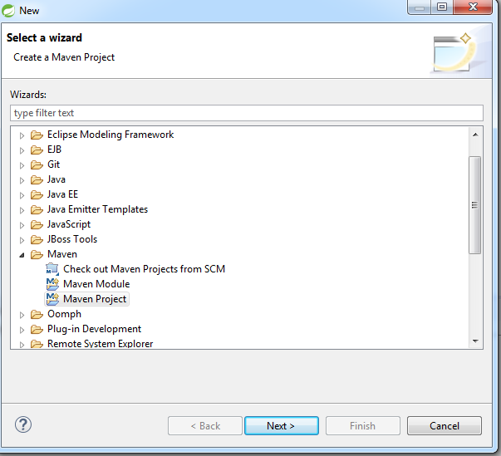

Step:-2) Click Next – Next - button

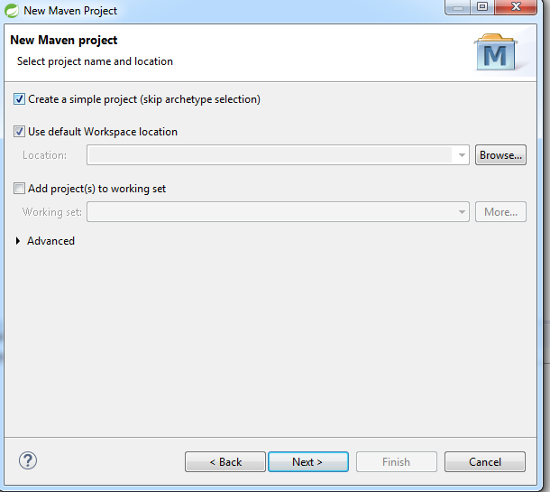

Step:- 3) Give Group Id and Artifact Id and Click on Finish Button.

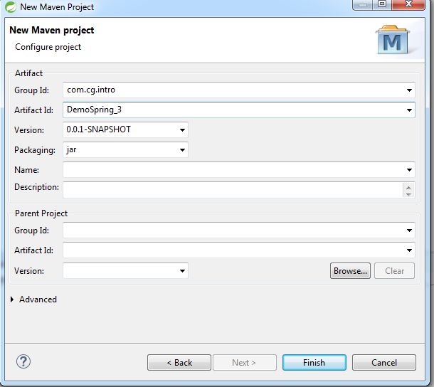

Step:- 4) In Maven Project initial pom.xml file created is as follows.

<project xmlns=*"http://maven.apache.org/POM/4.0.0"* xmlns:xsi=*"http://www.w3.org/2001/XMLSchema-instance"* xsi:schemaLocation=*"http://maven.apache.org/POM/4.0.0 http://maven.apache.org/xsd/maven-4.0.0.xsd"*>

<modelVersion>4.0.0</modelVersion>

<groupId>com.cg.intro</groupId>

<artifactId>DemoSpring_3</artifactId>

<version>0.0.1-SNAPSHOT</version>

</project>

Step: - 5) Add the spring related dependencies in Pom.xml as follows.

* + 1. Open pom.xml- > Click on Dependency tab -> Click on Add Button.
    2. Add the following dependencies and click on OK button

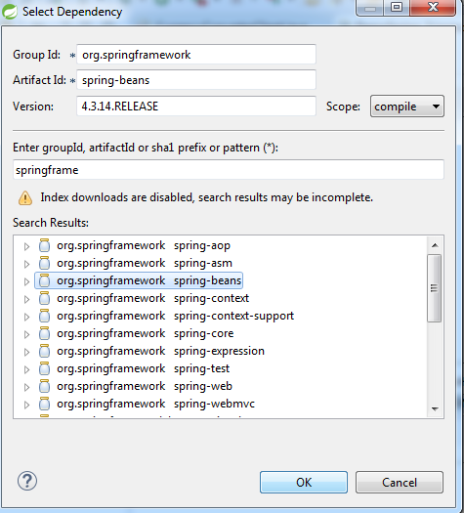

After Adding all dependencies pom.xml look like as follows.

<project xmlns="http://maven.apache.org/POM/4.0.0" xmlns:xsi="http://www.w3.org/2001/XMLSchema-instance" xsi:schemaLocation="http://maven.apache.org/POM/4.0.0 http://maven.apache.org/xsd/maven-4.0.0.xsd">

<modelVersion>4.0.0</modelVersion>

<groupId>com.cg.intro</groupId>

<artifactId>DemoSpring_3</artifactId>

<version>0.0.1-SNAPSHOT</version>

<dependencies>

<dependency>

<groupId>org.springframework</groupId>

<artifactId>spring-beans</artifactId>

<version>4.3.14.RELEASE</version>

</dependency>

<dependency>

<groupId>org.springframework</groupId>

<artifactId>spring-context</artifactId>

<version>4.3.14.RELEASE</version>

</dependency>

<dependency>

<groupId>org.springframework</groupId>

<artifactId>spring-core</artifactId>

<version>4.3.14.RELEASE</version>

</dependency>

</dependencies>

</project>

Note:-In case of any errors in pom.xml.

Select the Project-Right Click on Maven- Update Project and –Select Force Update option

Use MVN Installed Option in case of any errors

Step:- 6) After Creating the Maven Project -Go to project’s src – main - resources folder and Right Click on it – Select New - Others - Spring - Spring bean Configuration File- Click on Next

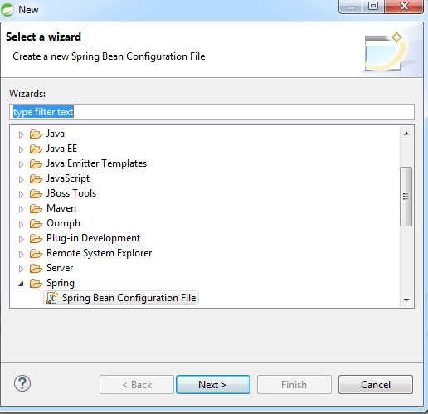

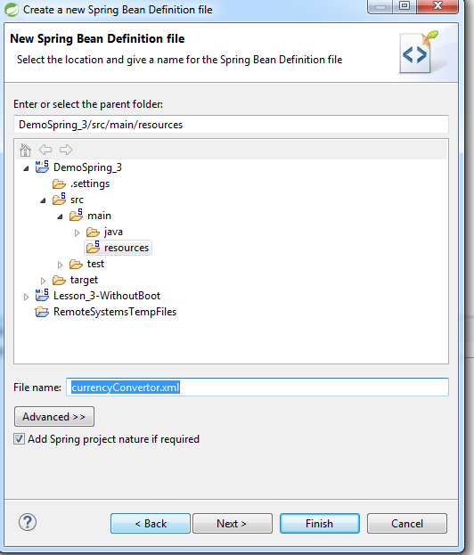

Give a Xml file Name -Click On next

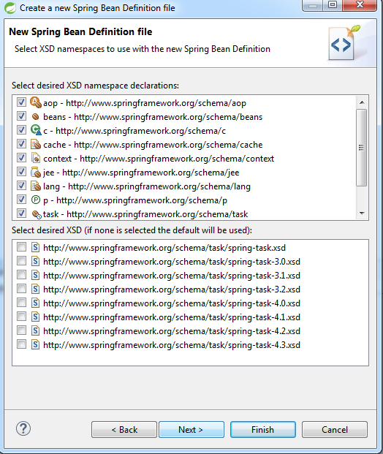

Select namespaces required and Click on finish.

Step: -7) Create java classes in Project\src\main\java folder .

1. Create Simple Spring project in STS Using Spring legacy project

Note:-Initially May Require Internet Connection For Local Repository

Step:-1) Go To New -Others - Spring Legacy Project - Click on Next.

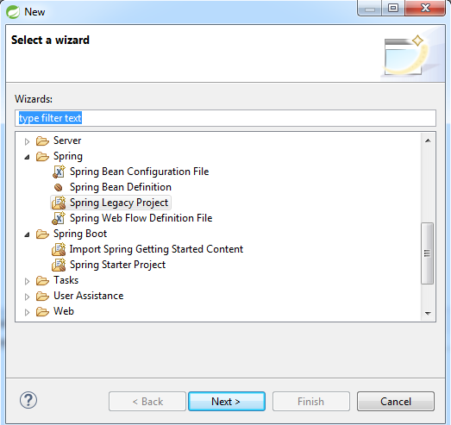

Step :-2 ) Give Project Name - Select Simple Spring Maven - Click On Finish Option.

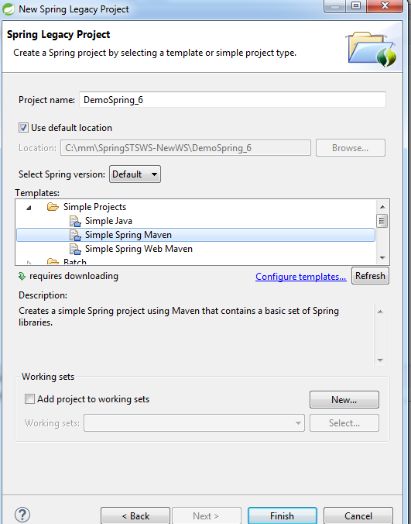

Step :-3) After Creation of Simple Spring Maven project create java classess in project\src\main\java folder and xml files in the projecs\src\main\resources folderes as follows.

Go To New –Others - Spring - Spring Bean Configuration Files - Click On Next

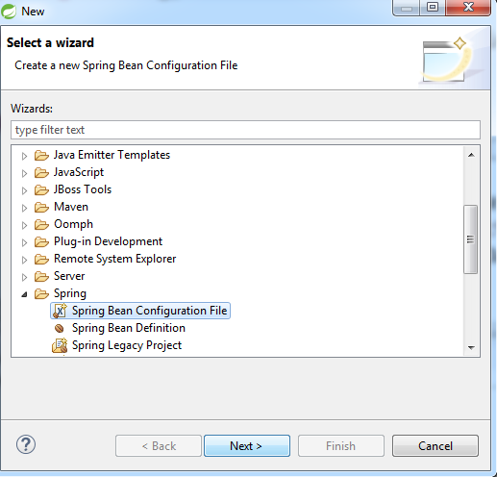

Give xml File Name - Click On Next as follows

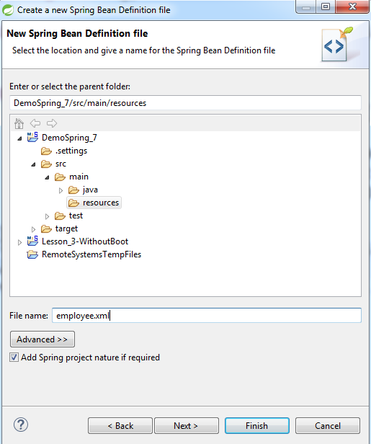

Select the namespaces require in the xml file And Click On Next - Finish.

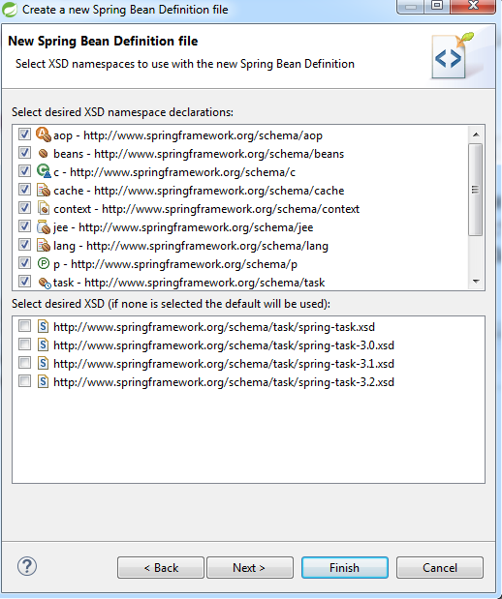

1. Steps To Create Spring Boot project

NOTE:-Need Internet connection to Create this project

Step:-1) - Go To New –Others - Spring Boot - Spring Starter Project- Click on Next

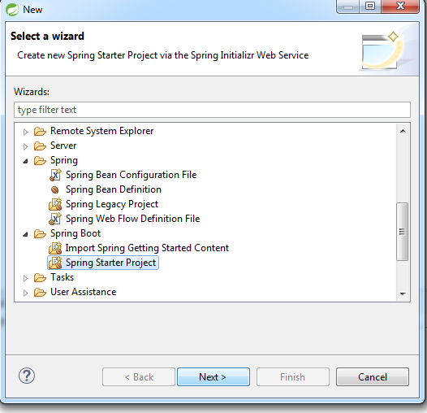

.

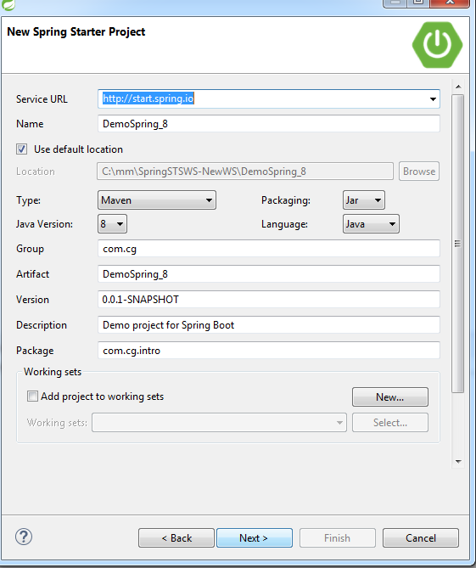

Again Click On Next- Select Web option - Click On Next

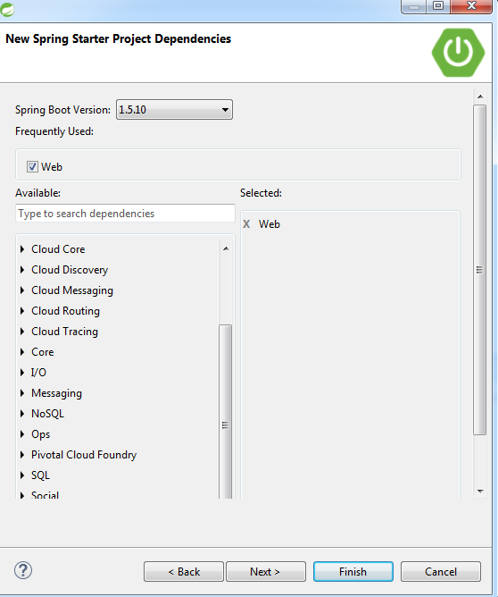

Click On Finish

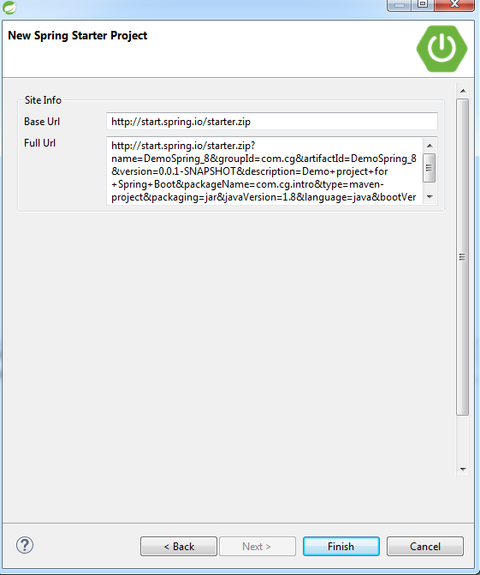

1. Steps To Create Spring MVC project

Step-1)For Creating Spring MVC project Go to New- select “Spring Legacy Project option”

Give a project name and click on nEXT button

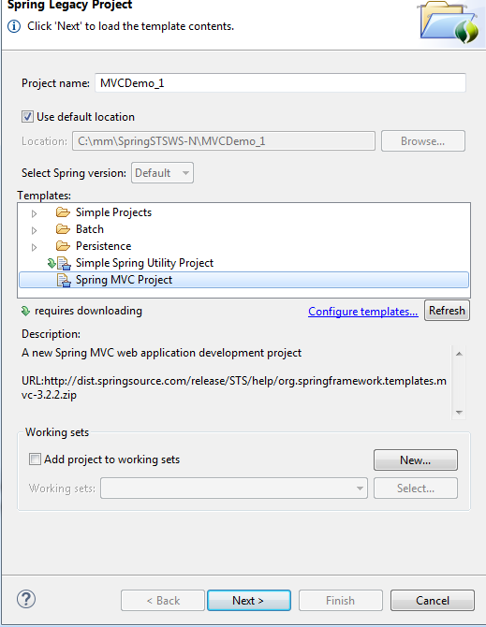

Give a package name as follows and click on finish button.

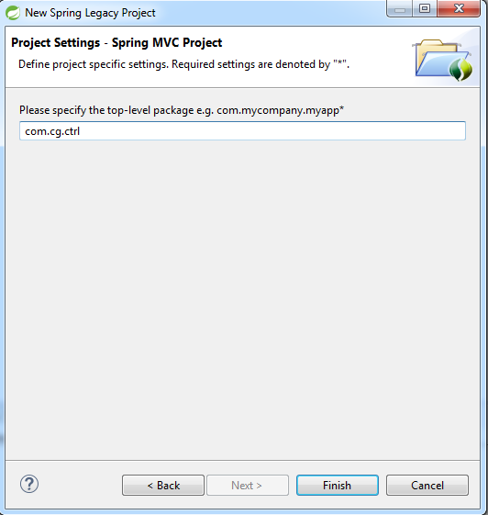

Project structor for MVC with web.xml and pom.xml is created.